# **Module 5) HTML5**

# Q 1] What are the new tags added in HTML5?

# Ans} There are many tags added in HTML5. That is:-

# <article>

# This tag represent the independent part of a document and this defind the newspaper article or magazine.

# <aside>

# <aside> tag gives a different text in a HTML it will gives a box in a HTML. <aside> tag shown in a different place .

# <audio>

# <audio> tag show a audio file in HTML5. If you give a <audio> tag it will give you audio file.

# <canvas>

# This tag is used to draw the graphics. It shows the box to draw the graphics. You have to used javascript to draw something in this canvas box.

# <command>

# <command> tag used to write the command in HTML5.

# <datalist>

# <datalist> have a pre-defined options for an <input> element.

# This tag gives you inbuilt drop-down list.

# This tag have a list.

# <details>

# Represents additional information and more details which user can demand.

# <embed>

# The <embed> tag defines external resource , like web page , video , image , etc.

# <figure>

# This tag is used to show position in document is related to the main flow.

# <footer>

# This <footer> tag is used to show the footer in a website.

# <footer> tag involves copyright , author .

# <header>

# <header> tag show the header area in a web page.

# This tag include navigation or main pages.

# <hgroup>

# Represents the header of a section.

# <keygen>

# This tag is used to control for key pari generation.

# <mark>

# This <mark> tag is used to mark the text . This tag highlight the tag which you want to highlight.

# <meter>

# Represents a measurement.

# <nav>

# This <nav> tag used to show the navigation bar.

# <output>

# This tag defind the output.

# <section>

# This <section> tag represent document or application section.

# <time>

# <time> tag represent date or time.

# <video>

# This <video> tag used to show the video file.

# Q 2] How to embed audio and video in a webpage?

# Ans} To embed audio in a web page use a audio tag in a HTML.

# To embed video in a web page use a video tag in a HTML.

# You can put any audio or video using of embed tag.

# This tag gives controls also in a web page.

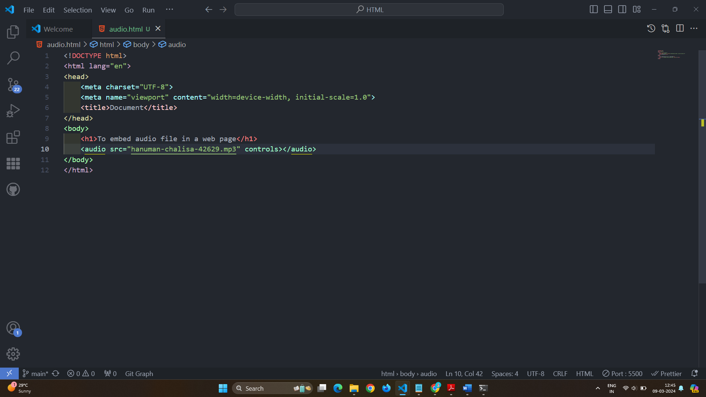

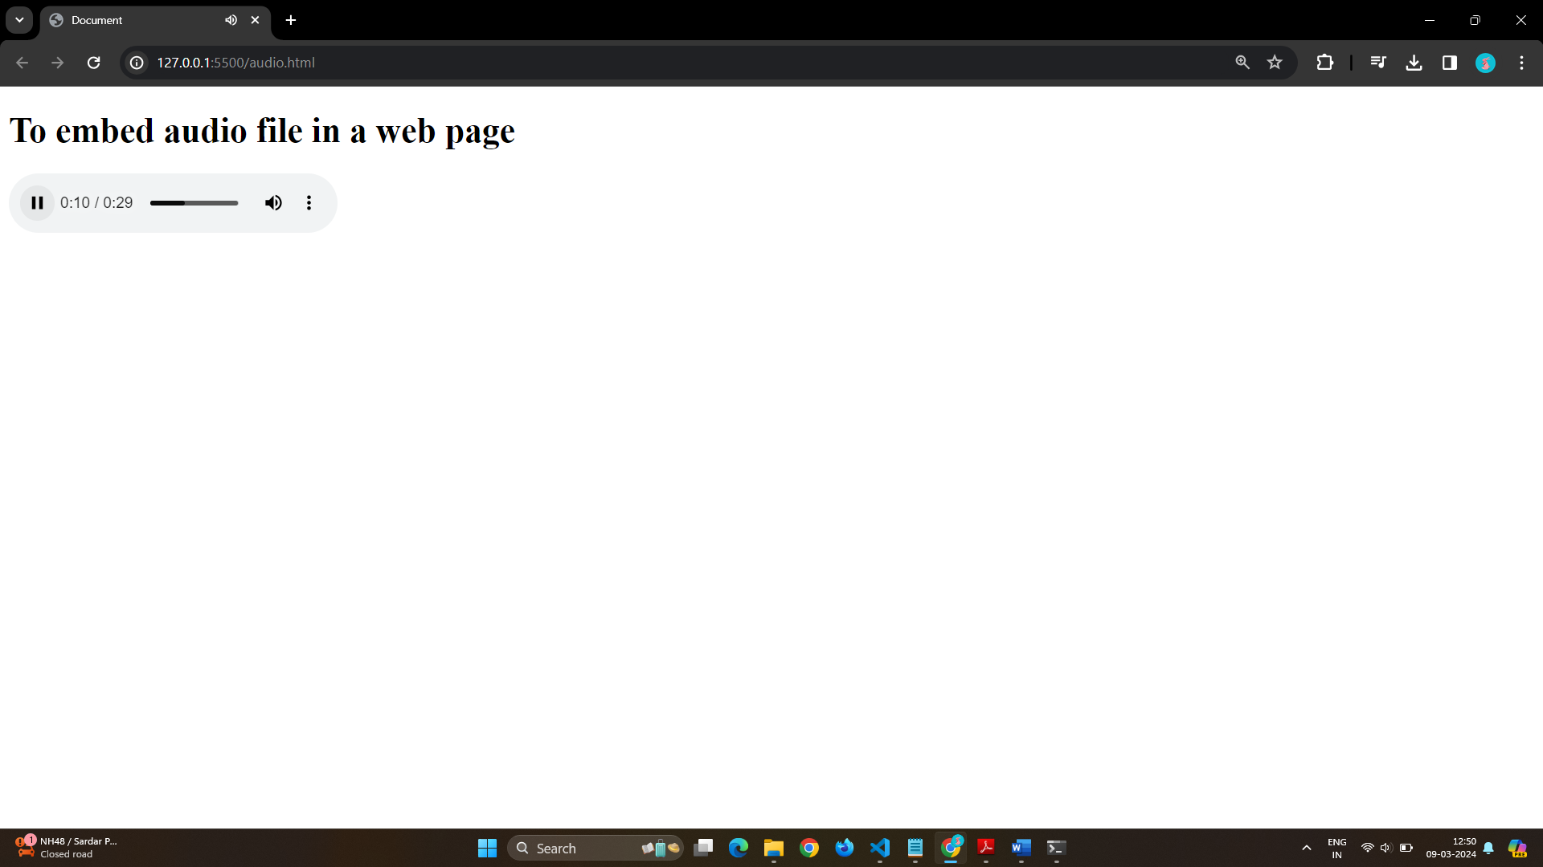

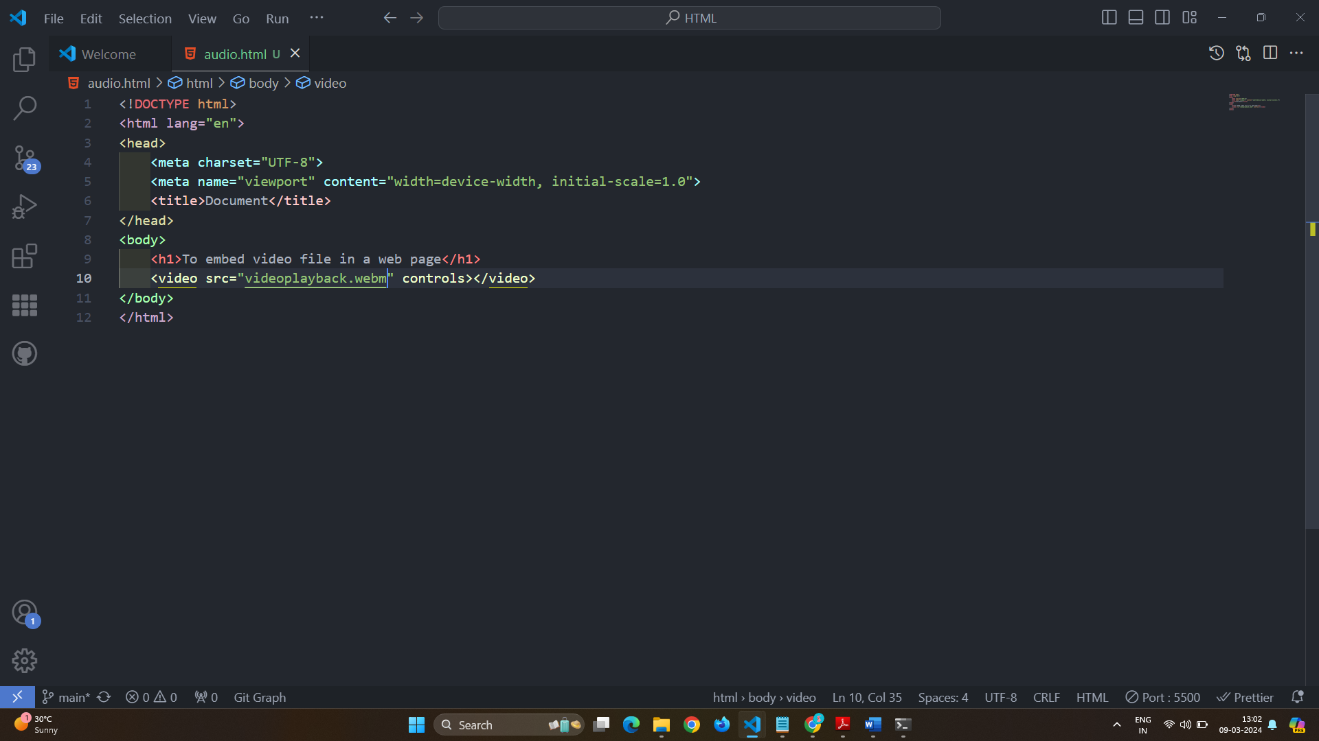

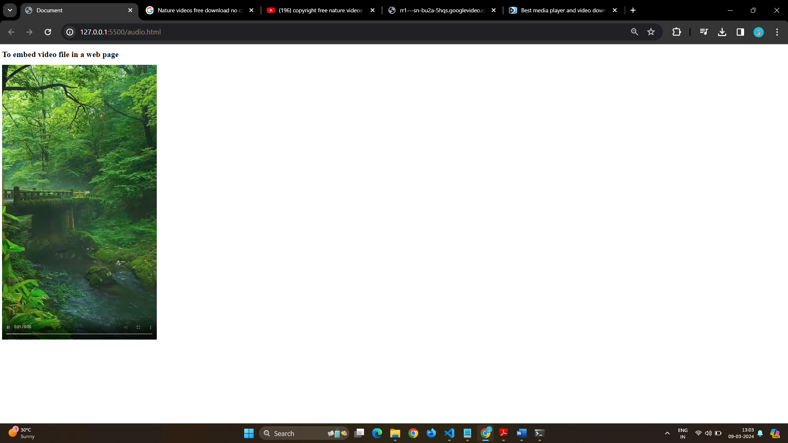

# Q 3] Semantic element in HTML5?

# Ans} Sematic element shows the different parts of a web page.

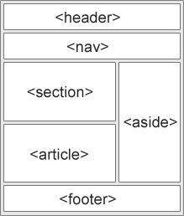

# Sematic element like <table> , <form> , <article> , etc.

# Sematic element shows the different part of web page like

# <header>

# <header> show the header part in a web page .

# <main>

# You can use main for show the main content.

# <footer>

# <footer> shows the copyright and author.

# Q 4] Canvas and SVG tags.

# Ans} Canvas:-

# Canvas gives the container to draw the graphics.

# Canvas gives the box to draw the graphics.

# You have to add Javascript to draw something in a canvas

# container.

# Following is a example of a canvas

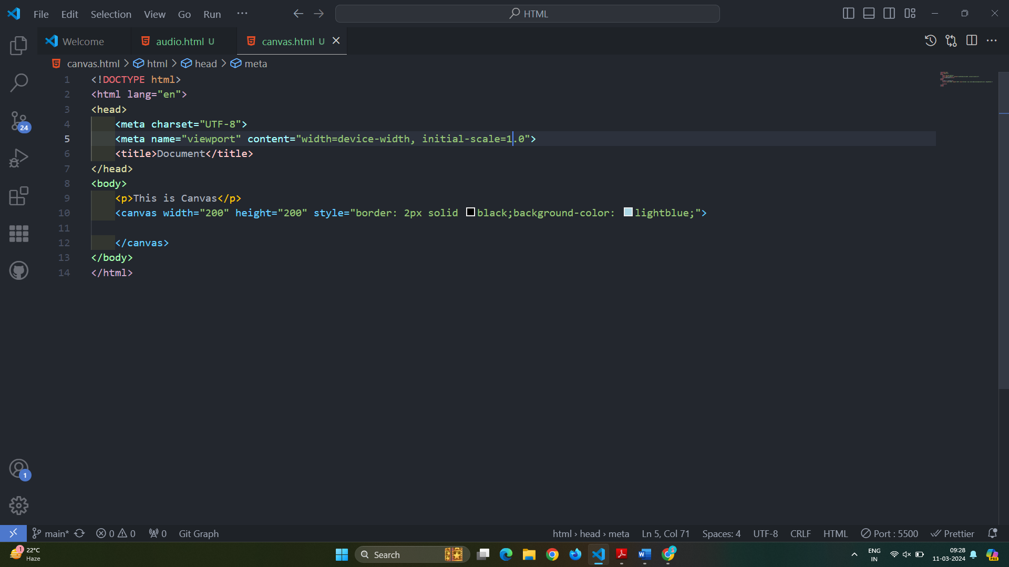

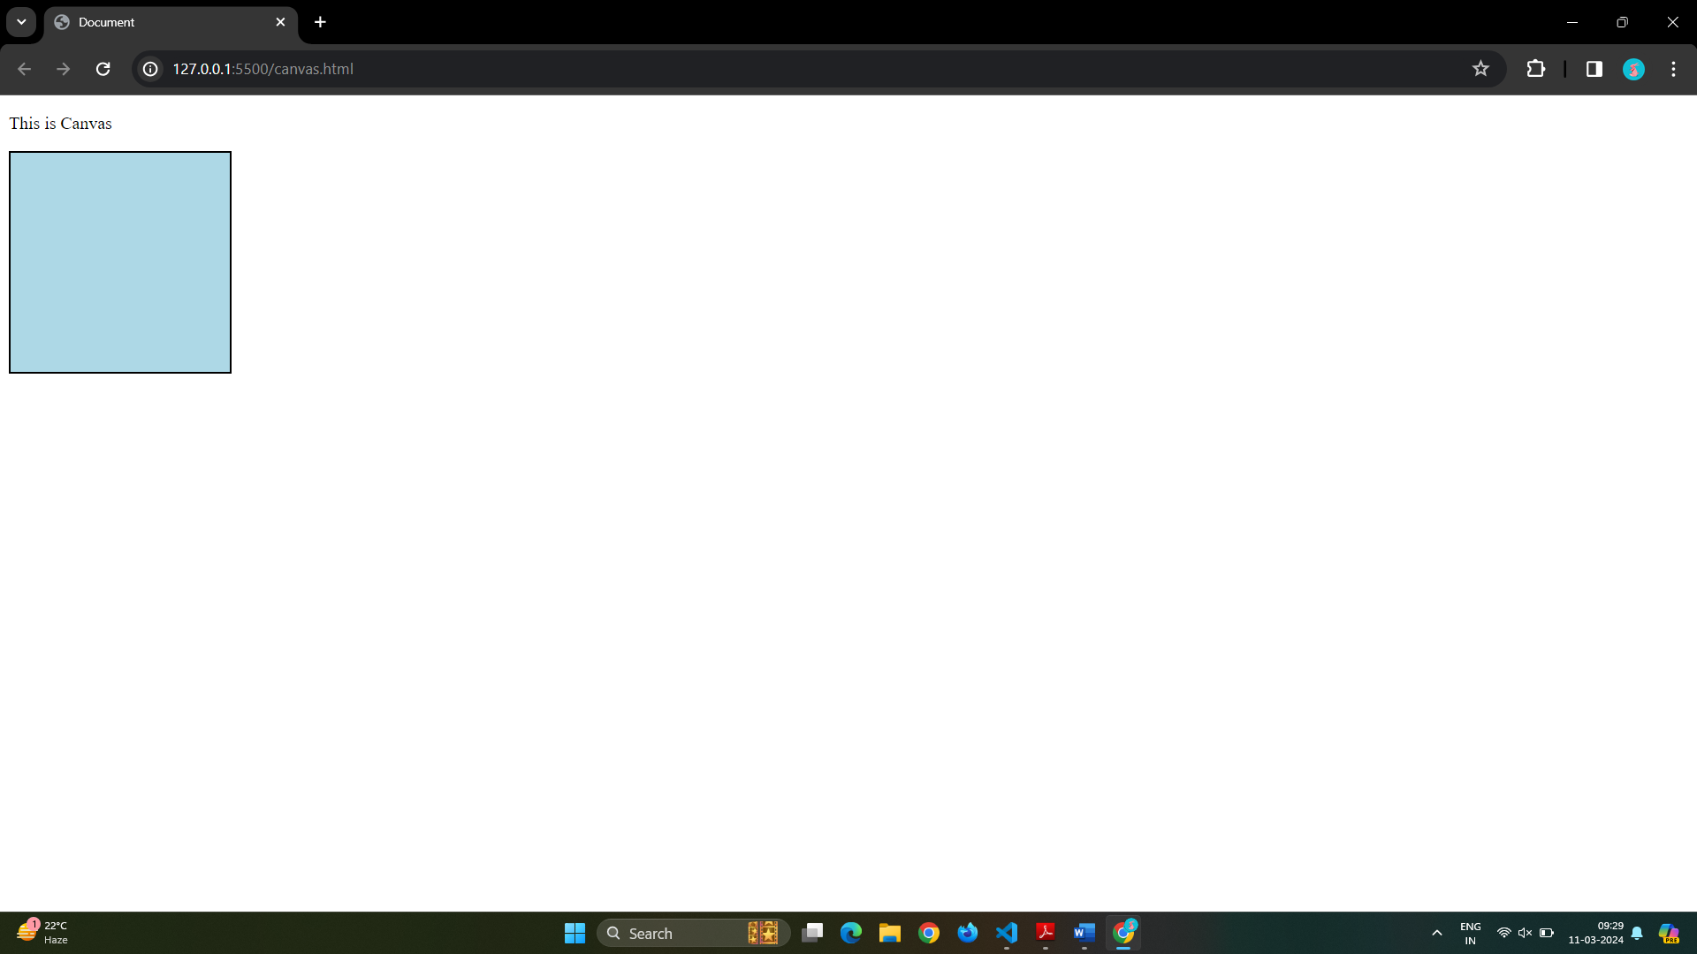

# SVG tags:-

# SVG have a many methods to drawing boxes , circles , text , graphics etc.

# Following is the example of SVG.

